**A Proposal for**

**Undergraduate Research Fellowships**

**Offered by the Wyoming EPSCoR Program**

**Autonomous Extension of Conventional Powered Wheelchair**

**for Independent Navigation**

**Author:**

Carter Schultz

**Project Summary:**

Typical powered wheelchairs provide a means of transportation for many with limited mobility. However, the traditional joystick control of these wheelchairs requires full mobility of the hand and wrist in order to be operated safely. This leaves those without this dexterity no viable transportation option. Autonomous wheelchairs attempt to fill this space in the marketplace.

An autonomous wheelchair is a robotic device; capable of navigating through a person’s home or office with little user input. Autonomous wheelchairs are designed to work with a variety of interface options, providing those with limited dexterity alternative means to control their wheelchair.

The flexibility and complex design of autonomous wheelchairs have made those currently available highly expensive. Ongoing research has been aimed at designing a cheaper, alternative control system that could be easily attached to an existing powered wheelchair. The goal of this project is to continue previous investigations and to create a functional autonomous wheelchair with a greatly reduced price point.

**Background:**

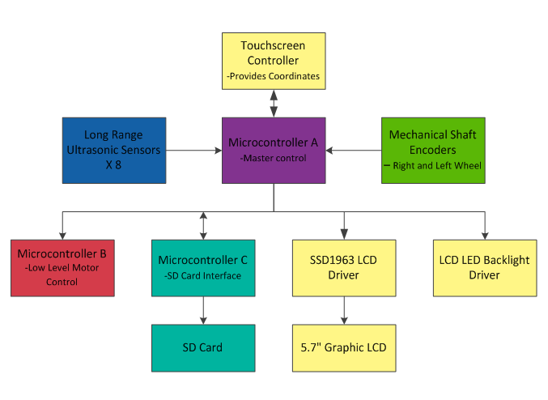 Previous efforts have been undertaken at the University of Wyoming to convert a conventional powered wheelchair into a functional autonomous wheelchair. These efforts have yielded a mostly completed electrical system and skeleton structures of code. The initial components of the electrical systems were developed by Dr. Steven Barrett. The project was then expanded by the work of Mr. Tyler Morton and Mr. Ben Hoerst. Further work was then performed by Dana Schultz and Kathleen Shea as part of their senior electrical engineering design project. Dr. Barrett first designed a module that allowed digital signals to override the conventional controls of a wheelchair. His initial work was augmented by a set of 10 sensors, 8 ultrasonic range detectors, and 2 rotary encoders. A control system was then designed featuring a resistive touchscreen LED display. This system was selected because it requires the least user interaction to provide navigation. Conventional button controls require a high level of hand dexterity to operate and require multiple interactions to select a destination. To handle the computational processes required by the project, a controls architecture was created using three microcontrollers. The microcontrollers can provide the needed computation ability at a fraction of the cost of using a full computer system.

Fig 1. Master Electrical Organization (Schultz, and Shea)

With the electrical system completed, Ms. Shea and Ms. Schultz then began developing skeleton code to define the behaviors of the wheelchair system. Their code created the basis of communication between the various modules used in the project. The foundational code they developed was able to prove that the electrical system and controls system they had designed was functional. With a functional conformation on the majority of their system Ms. Shea and Ms. Schultz began basic development on behavioral systems for the wheelchair.

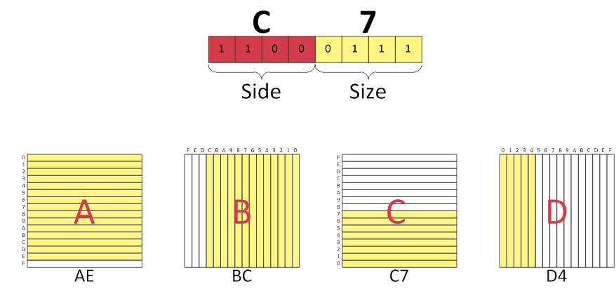 Initially the wheelchair navigation scheme was planned to function using a preprogramed map of its local environment, with the expectation that later development would allow the wheelchair to autonomously map its environment as well as navigate. The most efficacious system for this map was determined to be a feature map. A syntax for the feature map was selected based on the specific requirements of the wheelchair system. The selected encoding scheme maps an area with a character array where each cell of the array corresponds to a twelve inch square of planar space. The upper nibble of the character determines the direction from which any obstacle protrudes into the cell, and the lower nibble of the character defines the magnitude of the coverage of the obstacle within the cell. Fig 2 depicts the encoding system for the map system.

Fig 2. Map Encoding (Schultz, and Shea)

The map encoding system was the last major portion of the wheelchair project completed by Ms. Schultz and Ms. Shea before time constraints concluded their research. At the current time the wheelchair system has all of the major components designed and implemented. However, major testing has yet to be completed and an overall control system has yet to be created.

**Scope of Project**

The primary objective of the proposed research is to continue the development of a low cost autonomous wheelchair. The first objective of the project is to complete integration of the disparate components and verify the proper function of the controls architecture. The second objective is to create a user interface for control of the system including a non-autonomous pilot interface to allow manual control of the wheel chair through the touchpad interface. The third objective is to investigate and develop preliminary autonomous behaviors including: A* path planning, odometric reckoning and correction, and environmental mapping. The completion of these objectives would verify that a low cost autonomous wheelchair is a feasible and effective product.

Integration of the project’s various elements is the last major developmental step before full systems testing can be completed. This integration will require the development of communication schemes between the various microcontrollers as well as creation of extensive code modules that will lay a foundation for the development of advanced behavioral code. Additionally, many errors have been documented in the existing code that will need to be corrected. Once these code modules are developed, and the electrical system is fully combined, the complete performance of the controls system can be verified. Each of the elements of the electrical system will need be characterized for ideal performance and testing will need to be conducted to confirm the operational abilities of the control system.

Currently the electrical system is laid out on a breadboard as a developmental system. This layout facilitates troubleshooting and integration steps but is not feasible for a final design. After the design of the controls system is fully validated, a more robust and compact version of the electrical system will need to be created. Investigations will need to be conducted to determine the appropriate method for developing this new design. Options include custom printed circuit boards, 3D printed enclosures, and proto-board assembly. Additionally the current electrical system is powered using an external power supply; a system will have to be created to either provide a supplemental battery power to the system or use a DC voltage transformer to use the power from the existing lead acid batteries. The development of a prototype portable control system will allow the system to leave bench top testing and began real world testing.

Concurrent to the integration of the system will be the development a complete code package for operation of the system. Initial code modules developed previously will need to be combined into a single and cohesive project. The final validation of the controls architecture will require a complete test where the wheelchair is piloted solely through inputs to the LCD touch screen. After the completion of this test, the development of a Graphical User Interface or GUI will be required. A GUI provides users with feedback from the system and prompts to assist with interaction. The extremely limited processing capabilities of the microcontrollers require a lightweight and flexible GUI system to be designed. Features of the GUI will include: displays of map data and current position, menu systems, and calibration systems. The GUI will create the functional frontend of the system and will move the project one step closer to real world deployment.

The last remaining portion of the wheelchair system to be developed will be the autonomous behavior systems of the wheelchair itself. The autonomous navigation and mapping of an environment is one of the so called “golden problems of robotics” (Durrant-Whyte, Bailey). Typically referred to as Simultaneous Localization and Mapping or SLAM, the problem combines complex mathematical filtering of data with the known limitations of sensors to attempt to produce accurate and precise knowledge of an area. Many SLAM algorithms have been developed; however, most require extensive and complex computation. Porting an existing SLAM algorithm onto a microcontroller is an extremely difficult problem requiring complex code. A great deal of work will is necessary to determine the appropriate method for analysis of sensor data and the appropriate behavioral model that would allow the wheelchair to successfully and repeatedly navigate from position to position.

In addition to the problem of SLAM there is the problem of path planning. Once an environment has been mapped and the wheelchair position within that environment has been determined, calculations must still be performed to determine the path that a robot will take through its environment. One of the most common and effective algorithms for doing this is A* algorithm (Loong, Liew, and Hun). The A* algorithm has been used on microcontrollers before, however the implementation is a difficult process. The format of the A* Algorithm is shown in Fig 3. If an A* and SLAM algorithm can be effectively implemented on a microcontroller format, then the autonomous wheelchair developed at the University of Wyoming will have equal functionality of other autonomous wheelchairs at a fraction of the cost.

Fig 3. A* Format (Loong, Liew, and Hun)

**Potential Benefits of the Research**

The ability to navigate independently it a critical requirement for those with severe handicaps. The ongoing research at the University of Wyoming aims to create an improved solution to this problem. The ability to allow independence of motion to those with severe physical and mental handicaps is an incredible advancement, and by making a more cost effective and available autonomous wheelchair, the University of Wyoming will allow thousands of people to regain a portion of their lives lost to a handicap. This research holds the potential to fundamentally change the lives of thousands of people who are most in need of help.

Being able to conduct this research under the supervision of Dr. Barrett will be of untold benefit to me personally. Learning directly from a leader in to field of robotics engineering will be an invaluable experience. The cross disciplinary nature of this research, combining complex portions of electrical engineering, mechanical engineering, and computer science, will excellently prepare me for my future aspirations of development in the field of robotics. Through this research I will be able to build on my past robotics experience and extend my abilities into new fields and new disciplines.

**Works Cited**

Durrant-Whyte, Hugh, and Bailey, Tim. "Simultaneous Localization and Mapping (SLAM): Part I The Essential Algorithms." *University of Sydney*. (2006): n. page. Web. 30 Sep. 2012. <http://www-personal.acfr.usyd.edu.au/tbailey/papers/slamtute1.pdf>.

Loong, Wong, Long Liew, and Lim Hun. "A STAR PATH FOLLOWING MOBILE ROBOT." 4th International Conference on Mechatronics. 17-19 May 2011. Kuala Lumpur, Malaysia: Web. 30 Sep. 2012. <http://ieeexplore.ieee.org/stamp/stamp.jsp?tp=&arnumber=5937169>.

Schultz, Dana, and Kathleen Shea. "Mapping and Navigational Control for an Autonomous Wheelchair." (Apr 26, 2012): n. page. Print.

Morton, Tyler, and Ben Hoerst. "Autonomous Wheelchair." (May 4, 2011): n. page. Print.